

PROBLEM STATEMENT

Day 61 : Mux9to1v
Day 62 : Mux256to1
Day 63 : Mux256to1v
Day 64 : Hadd
Day 65 : Fadd
Day 66 : Adder3
Day 67: Exams/m2014 q4j
Day 68 : Exams/ece241 2014 q1c
Day 69 : Adder100
Day 70 : Bcdadd4

DAY:61 Mux9to1v
Problem Statement:
Module Declaration:
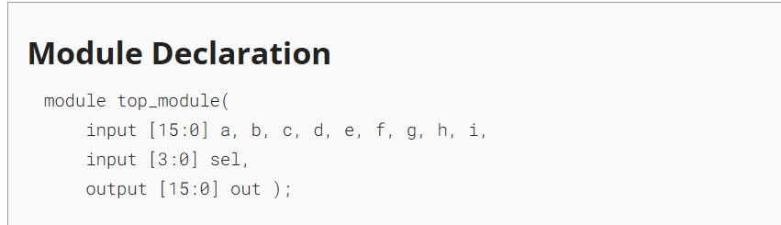Solution:
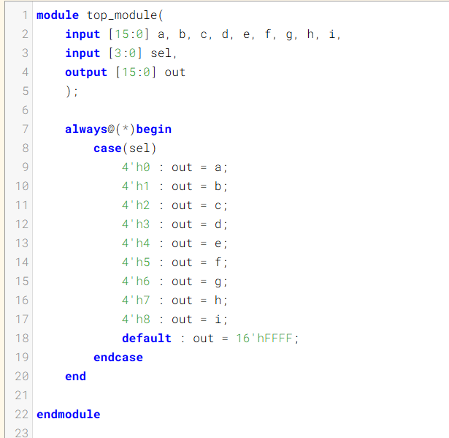

Code:
module top_module(
input [15:0] a, b, c, d, e, f, g, h, i,
input [3:0] sel,
output [15:0] out
);
always@(*)begin
case(sel)
4'h0 : out = a;
4'h1 : out = b;
4'h2 : out = c;
4'h3 : out = d;
4'h4 : out = e;
4'h5 : out = f;
4'h6 : out = g;
4'h7 : out = h;
4'h8 : out = i;
default : out = 16'hFFFF;
endcase
end
endmodule
Timing Diagram:
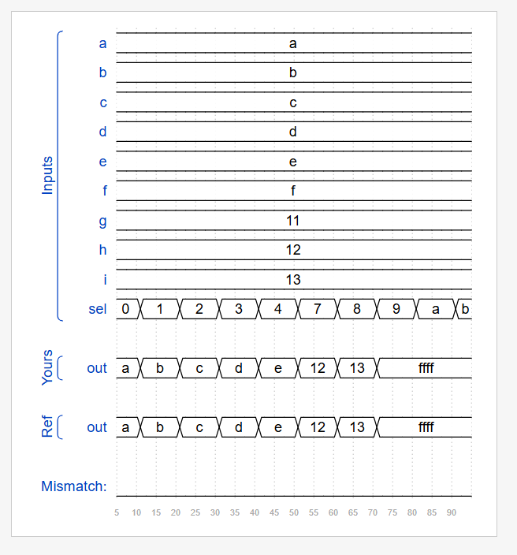

DAY:62 Mux256to1
Problem Statement:

Module Declaration:
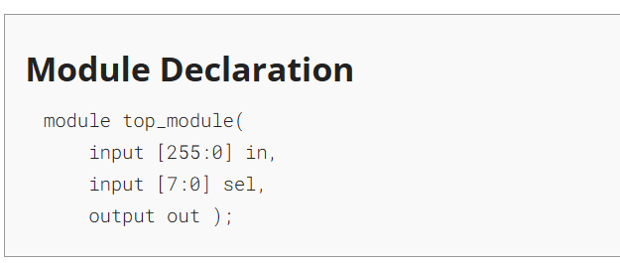

Solution:
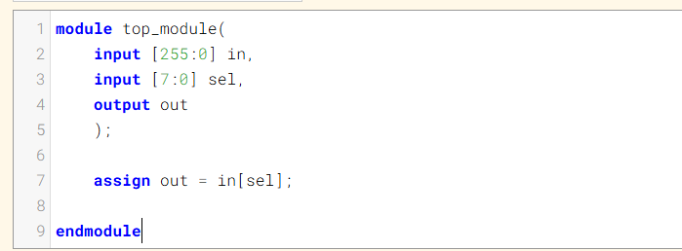

Code:
module top_module(
input [255:0] in,
input [7:0] sel,
output out
);
assign out = in[sel];
endmodule

DAY:63 Mux256to1v
Problem Statement:
Module Declaration:
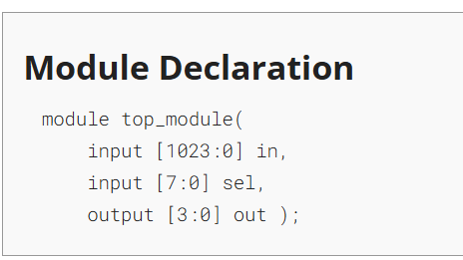
Solution:
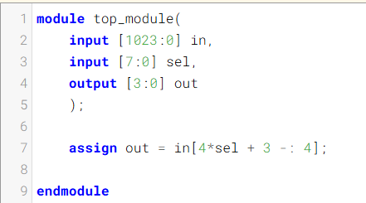
Code:
module top_module(
input [1023:0] in,
input [7:0] sel,
output [3:0] out
);

assign out = in[4*sel + 3 -: 4];

endmodule

DAY:64 Hadd
Problem Statement:
Module Declaration:
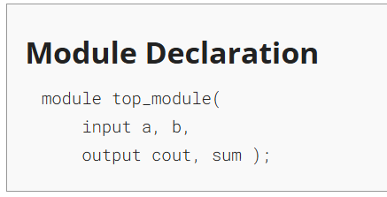
Solution:
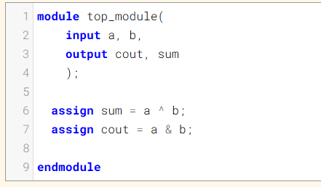
Code:
module top_module(
input a, b,
output cout, sum
);
assign sum = a ^ b;
assign cout = a & b;
endmodule

DAY:65 Fadd
Problem Statement:
Module Declaration:
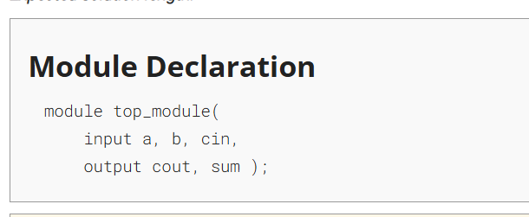

Solution:
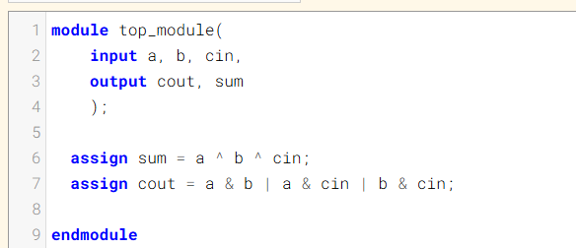
Code:
module top_module(
input a, b, cin,
output cout, sum
);

assign sum = a ^ b ^ cin;
assign cout = a & b | a & cin | b & cin;

endmodule

Timing Diagram:
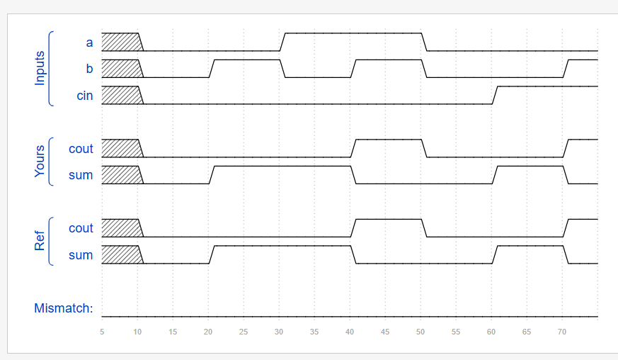

DAY:66 Adder3
Problem Statement:
Module Declaration:
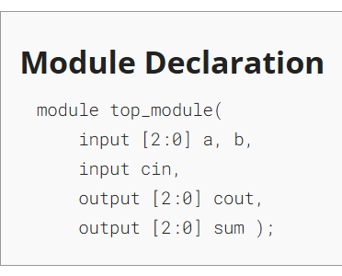
Solution:
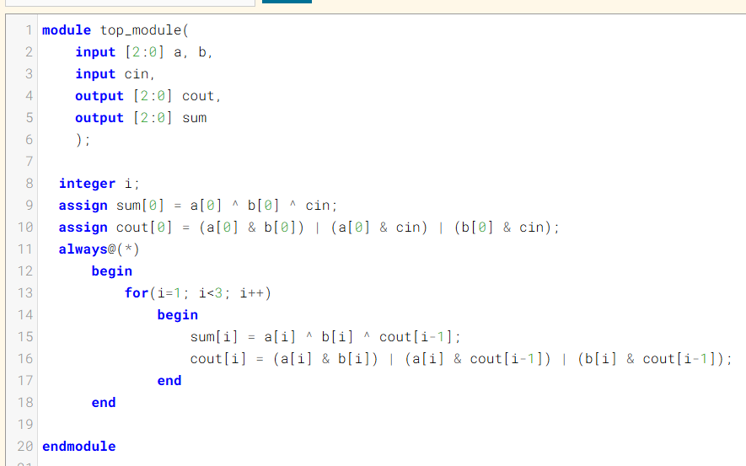
Code:
module top_module(
input [2:0] a, b,
input cin,
output [2:0] cout,
output [2:0] sum
);
integer i;
assign sum[0] = a[0] ^ b[0] ^ cin;
assign cout[0] = (a[0] & b[0]) | (a[0] & cin) | (b[0] & cin);
always@(*)
begin
for(i=1; i<3; i++)
begin
sum[i] = a[i] ^ b[i] ^ cout[i-1];
cout[i] = (a[i] & b[i]) | (a[i] & cout[i-1]) | (b[i] & cout[i-1]);
end
end
endmodule
Timing Diagram:
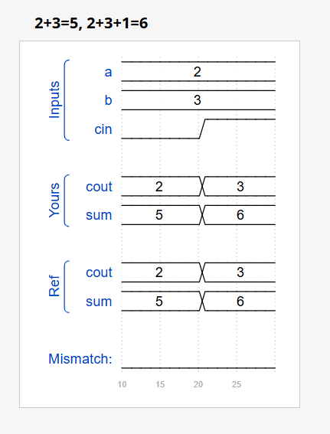
DAY:67 Exams/m2014 q4j
Problem Statement:
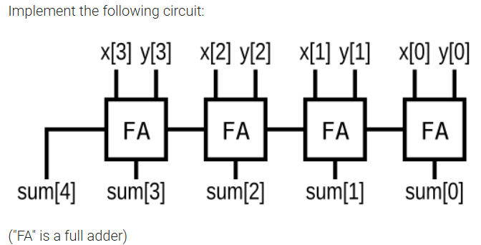
Module Declaration:
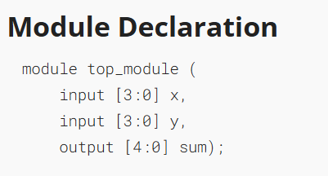
Solution:
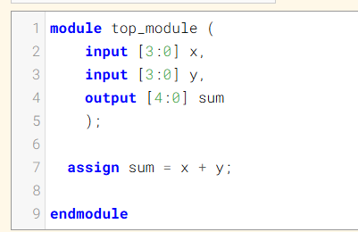
Code:
module top_module (
input [3:0] x,
input [3:0] y,
output [4:0] sum
);
assign sum = x + y;
endmodule
DAY:68 Exams/ece241 2014 q1c
Problem Statement:
Module Declaration:
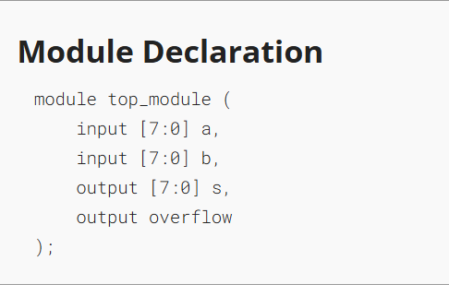
Solution:
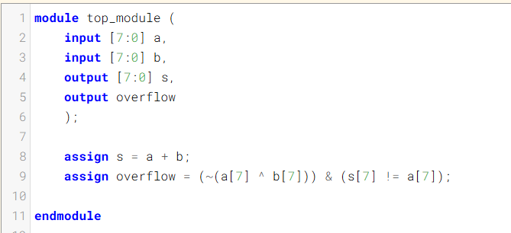

Code:
module top_module (
input [7:0] a,
input [7:0] b,
output [7:0] s,
output overflow
);

assign s = a + b;
assign overflow = (~(a[7] ^ b[7])) & (s[7] != a[7]);

endmodule
Timing Diagram:
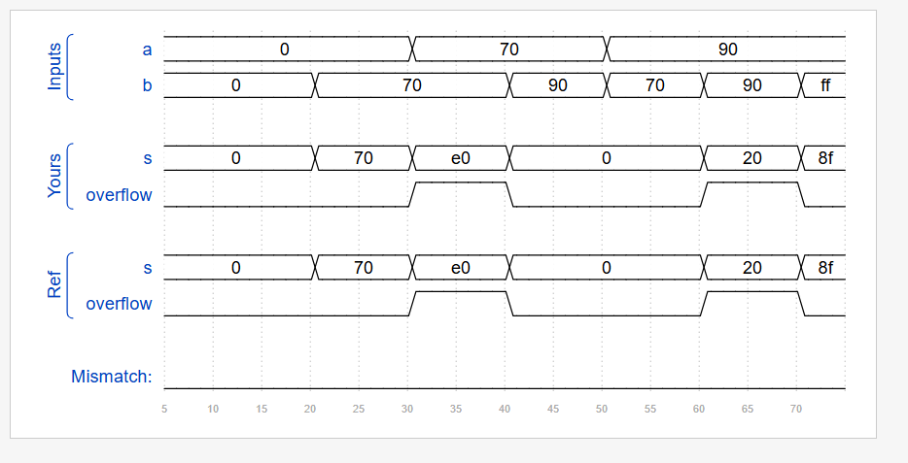
DAY:69 Adder100
Problem Statement:
Module Declaration:
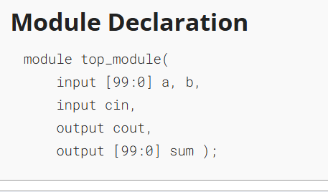

Solution:
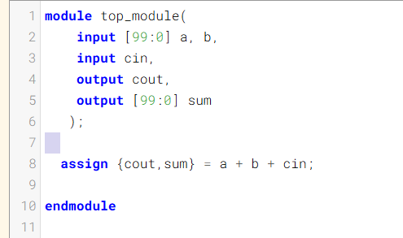
Code:
module top_module(
input [99:0] a, b,
input cin,
output cout,
output [99:0] sum
);

assign {cout,sum} = a + b + cin;

endmodule

DAY:70 Bcdadd4

Problem Statement:
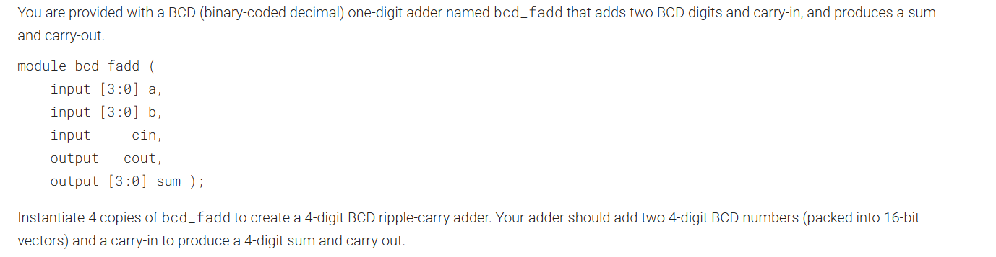

Module Declaration:
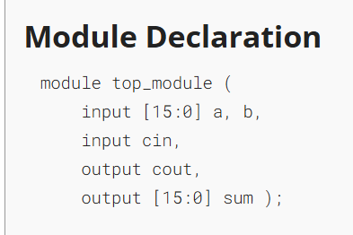

Solution:
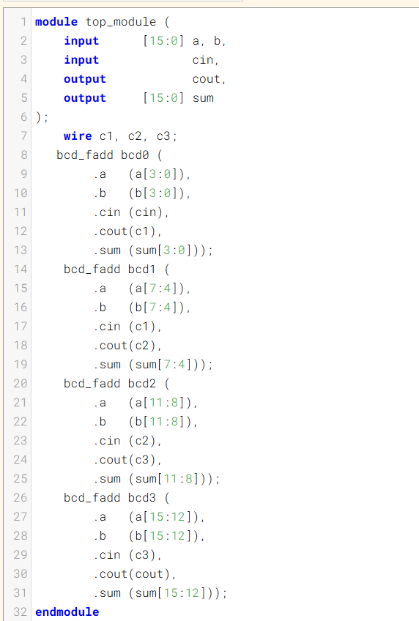
Code:
module top_module (
input [15:0] a, b,
input cin,
output cout,
output [15:0] sum
);
wire c1, c2, c3;
bcd_fadd bcd0 (
.a (a[3:0]),
.b (b[3:0]),
.cin (cin),
.cout(c1),
.sum (sum[3:0]));
bcd_fadd bcd1 (
.a (a[7:4]),
.b (b[7:4]),
.cin (c1),
.cout(c2),
.sum (sum[7:4]));
bcd_fadd bcd2 (
.a (a[11:8]),
.b (b[11:8]),
.cin (c2),
.cout(c3),
.sum (sum[11:8]));
bcd_fadd bcd3 (
.a (a[15:12]),
.b (b[15:12]),
.cin (c3),
.cout(cout),
.sum (sum[15:12]));
endmodule
Timing Diagram:
